**SCS2208 Rapid Application Development**



**Group Assignment 01**

**Group Members**

1. 21000395 – A. D. N. De Zoysa
2. 21000557 – D. G. D. Dissanayake
3. 21001022 – K. A. S. M. Kularathne
4. 21001032 – M. J. S. Kulathilaka

**GitHub Repo:** https://github.com/janindu-kulathilaka/RAD-Group-Project

**Google Drive link (Video):**

**Functionalities**

**Customer**

1. 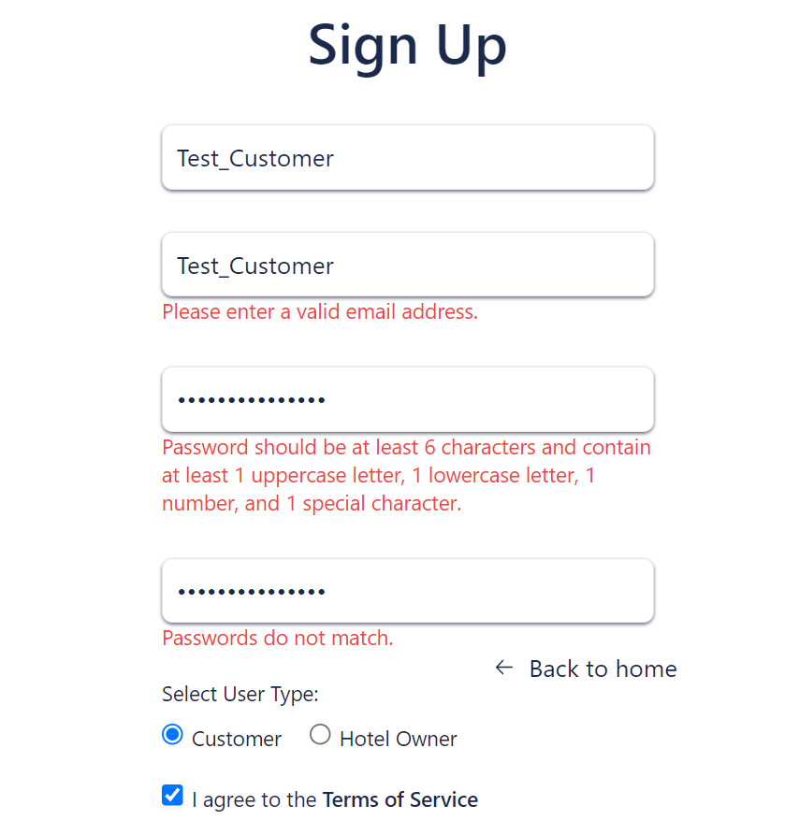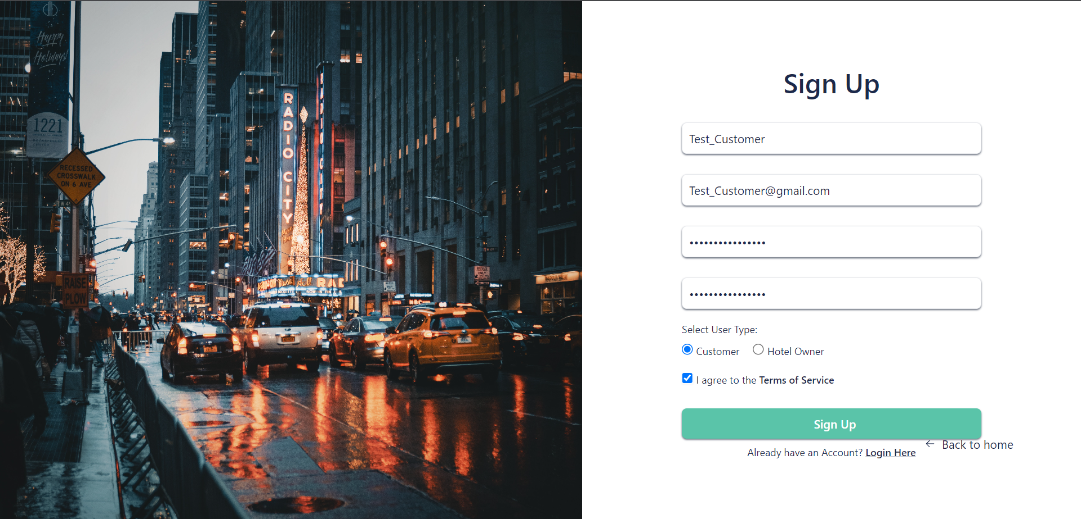Register as Customer  
     
     
     
     
     
   ***Validate user data***

* *The system check if the email is in the valid format*
* 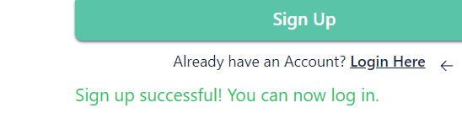*There are minimum requirements for a password(strength check)*  
    
    
    
    
    
    
    
    
   *Confirmations*

1. 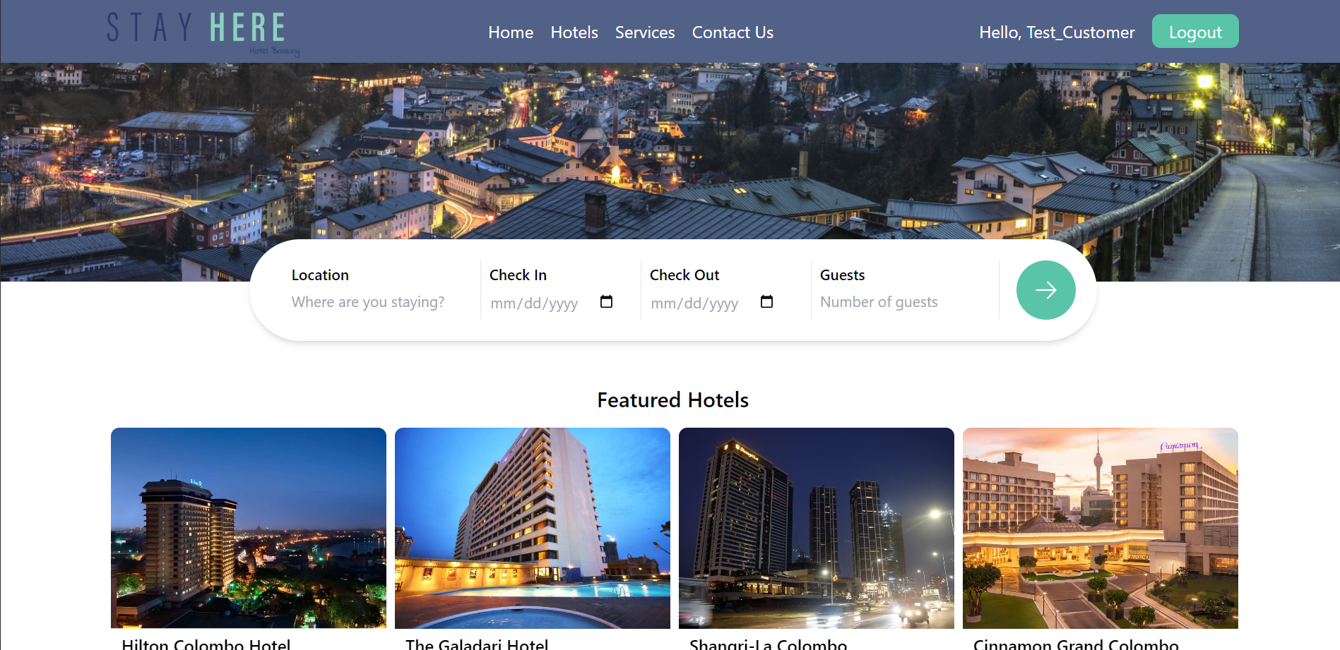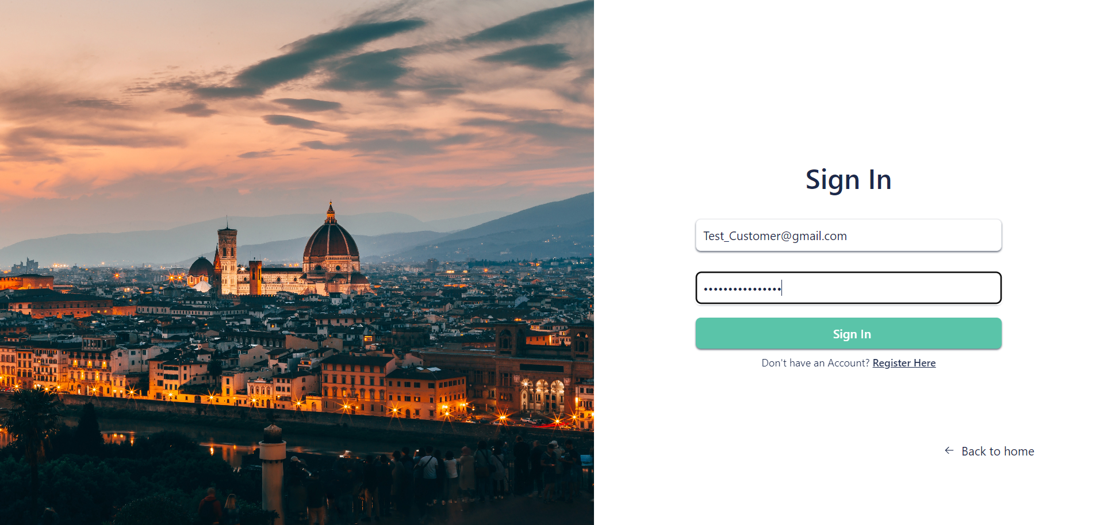Login
2. 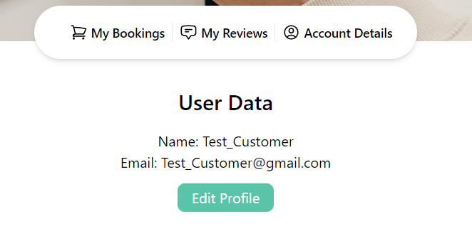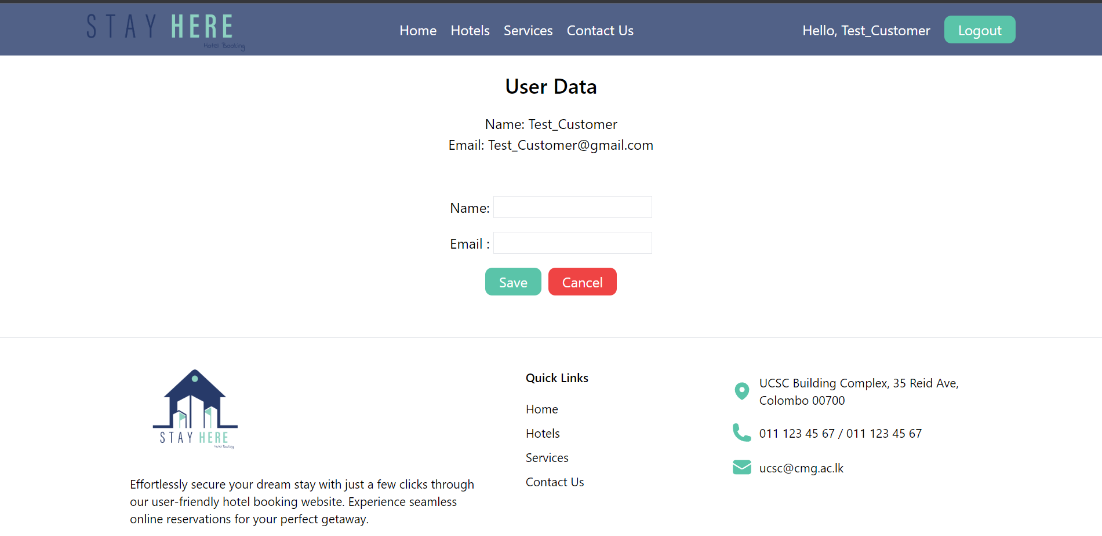 Edit user data  
     
     
   *Users can change their name and e-mail addresses.*
3. 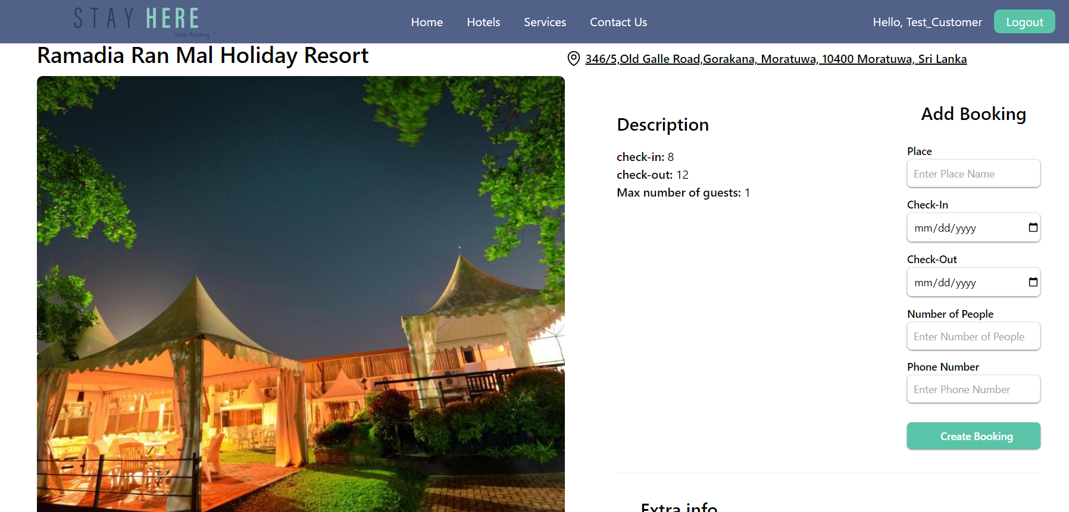View Hotels
4. Create a Booking

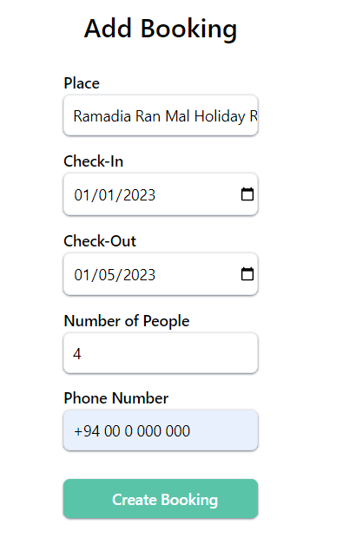

1. View/ Update/ Delete bookings

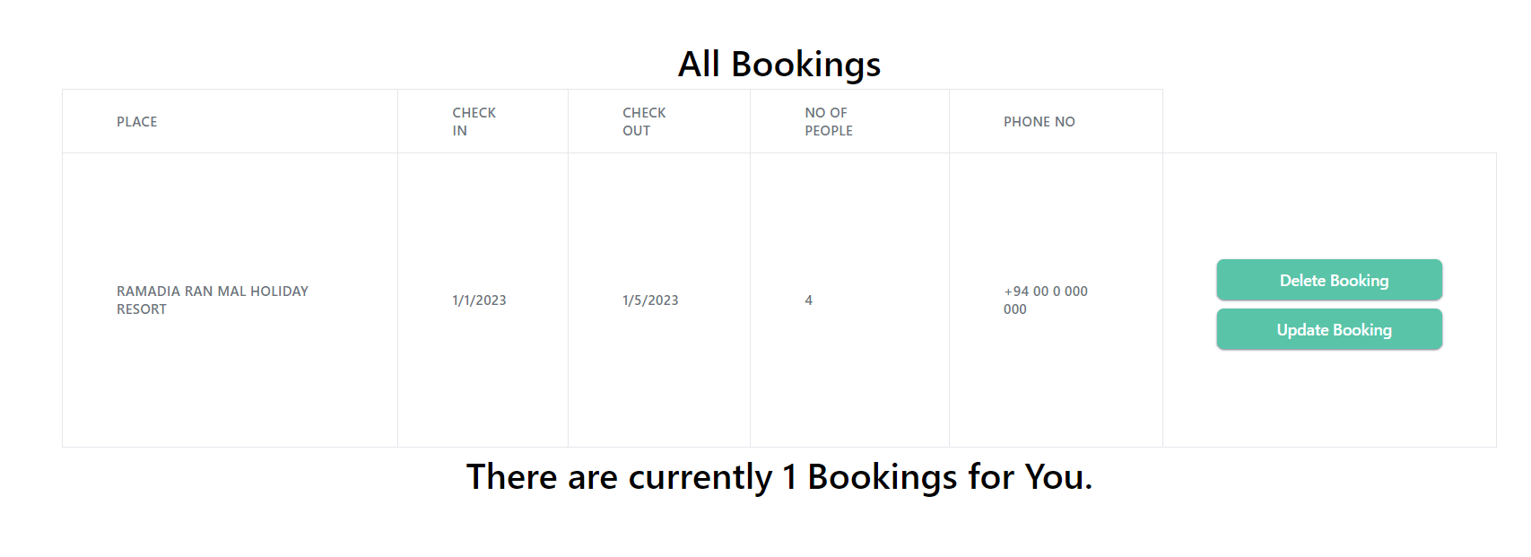

1. 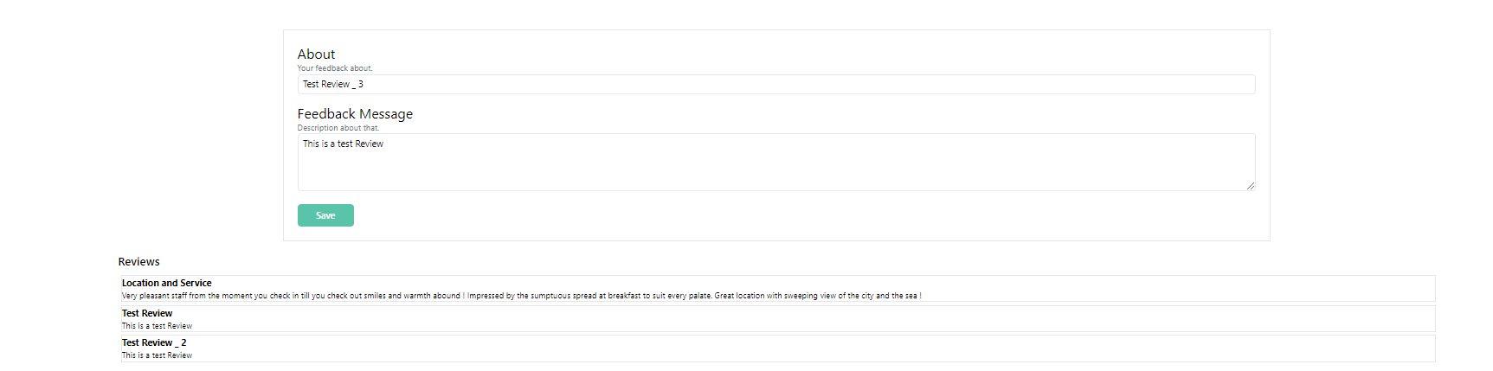 Leave a review under a hotel
2. 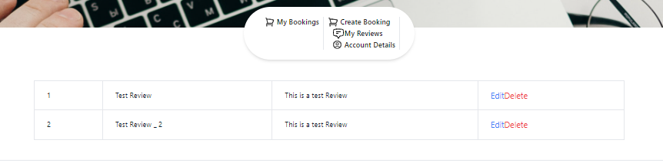View/ Edit or delete reviews
3. 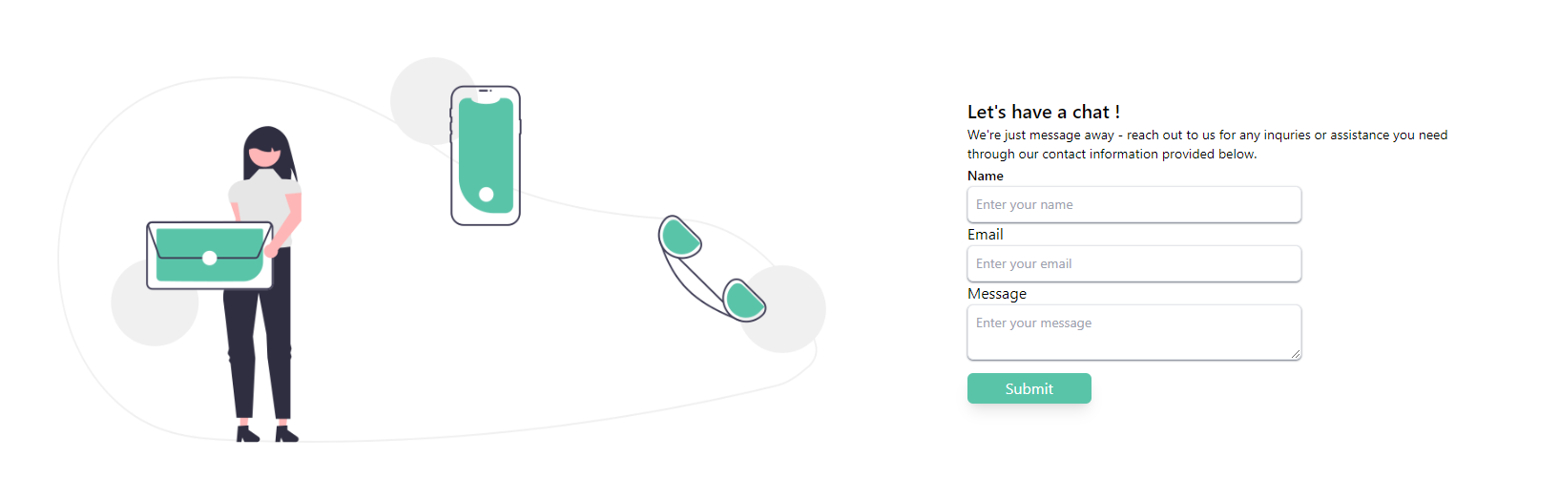 Send inquiries   
     
     
     
   *both customers and hotel owners can send inquiries to us regarding the issues they face.*

**Hotel Owner**

1. 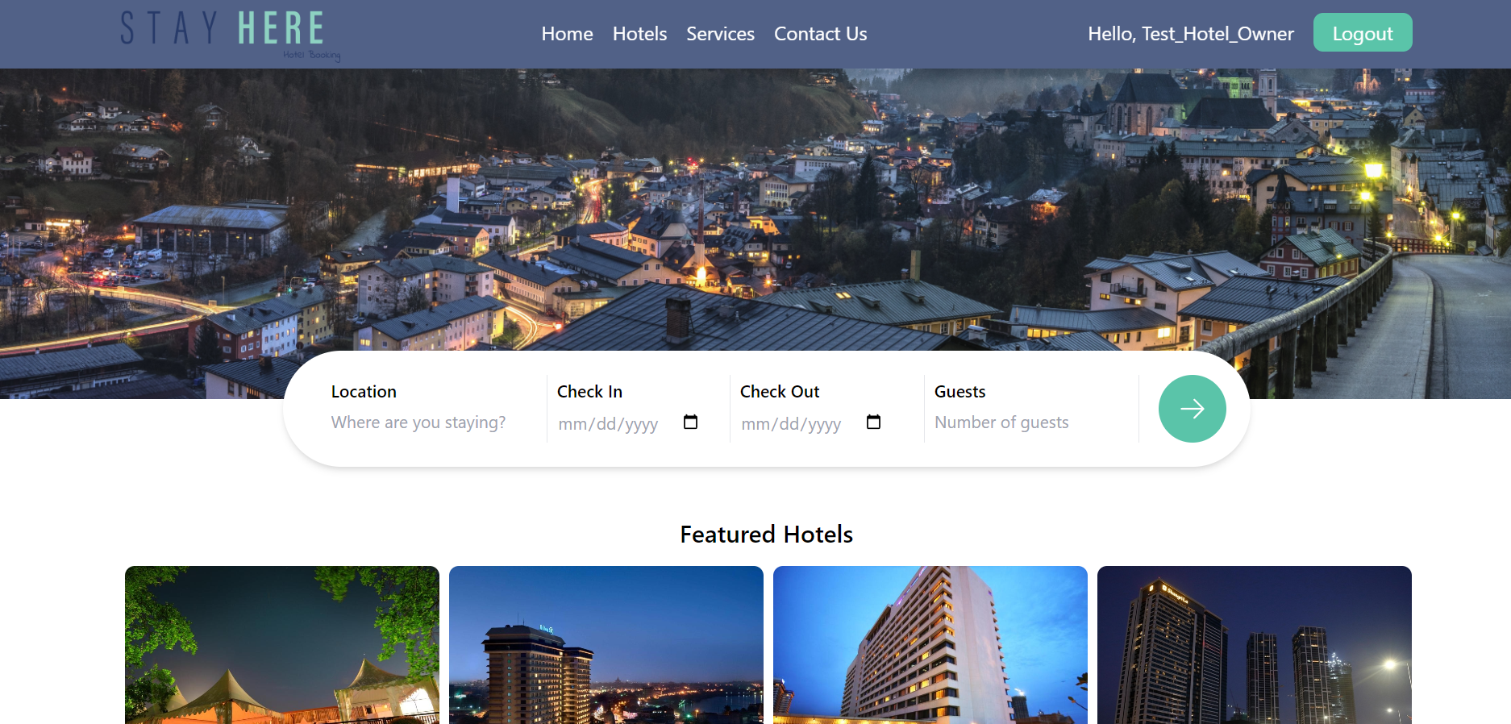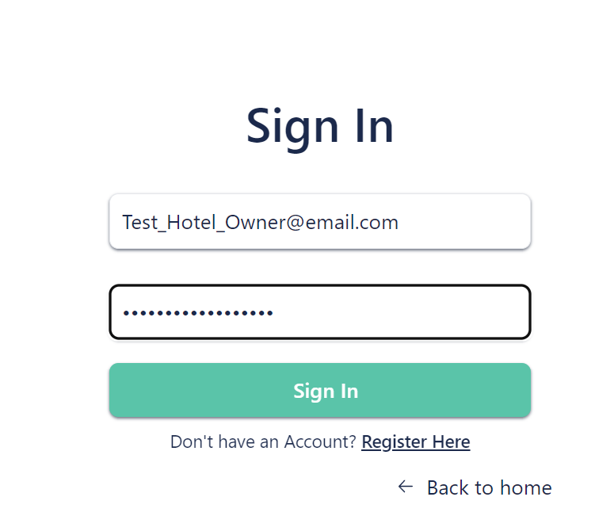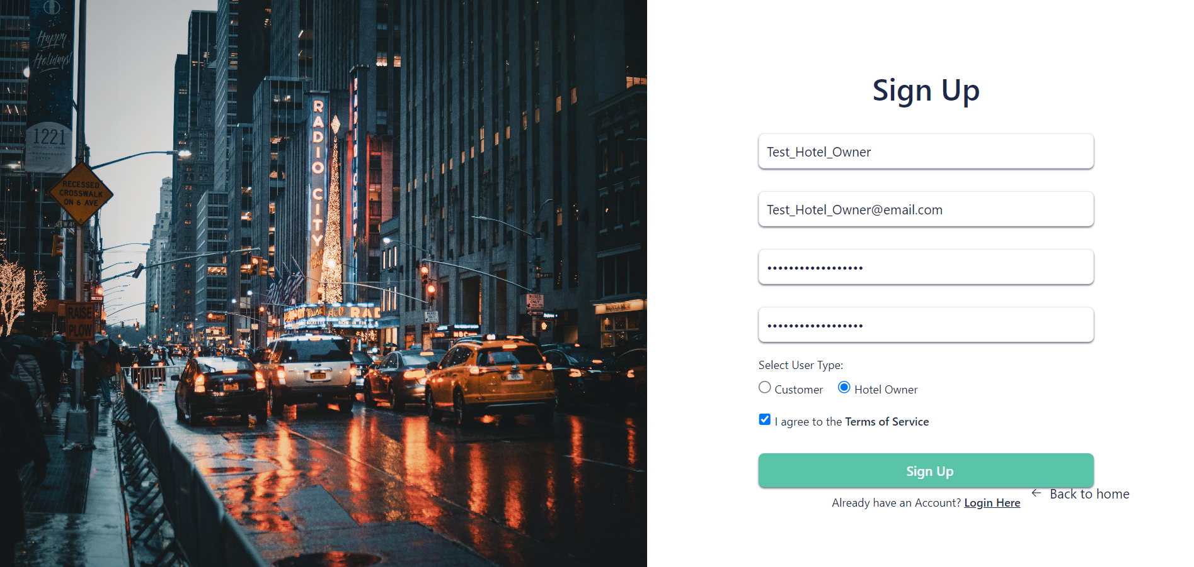Register/ Login
2. 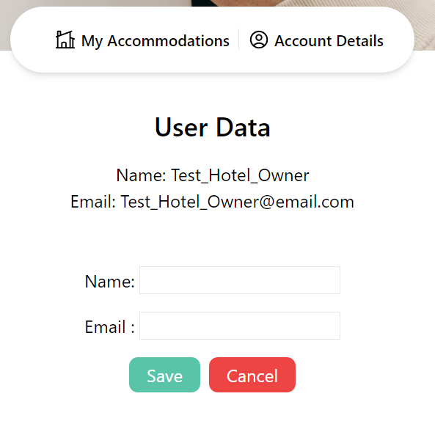Edit profile data
3. 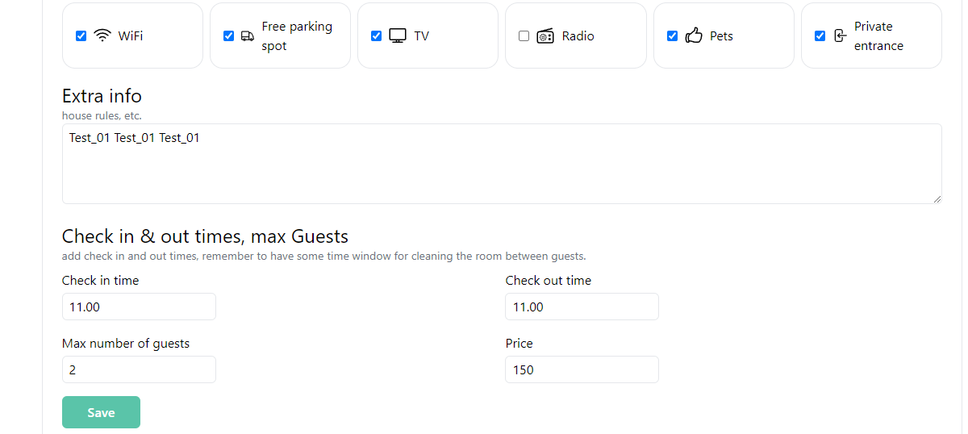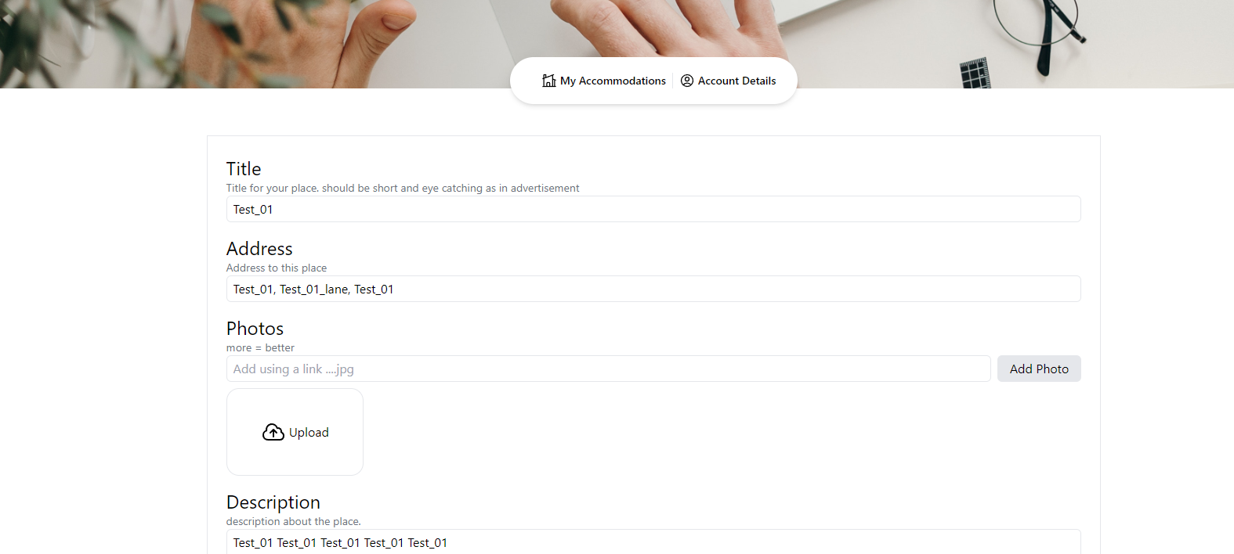Add accommodations
4. 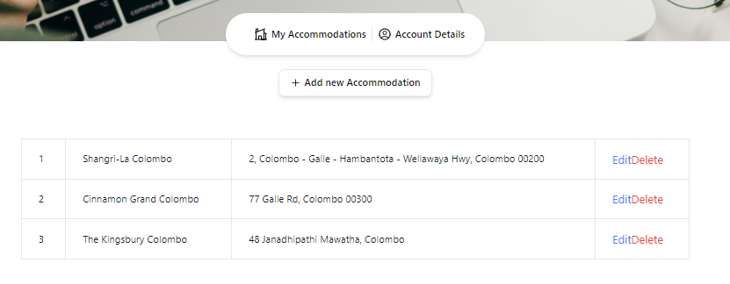View / Remove/ Edit accommodations

**Administrator**

1. 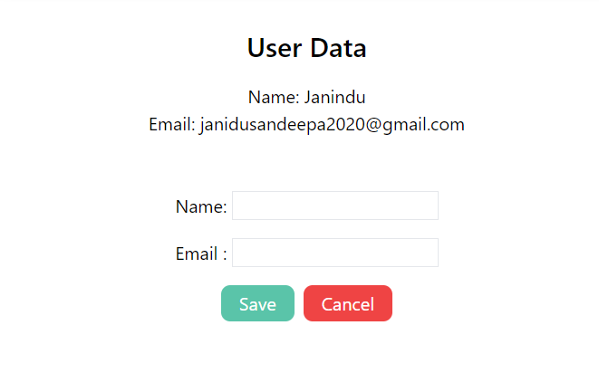Login / Edit Profile data
2. View/ Delete users

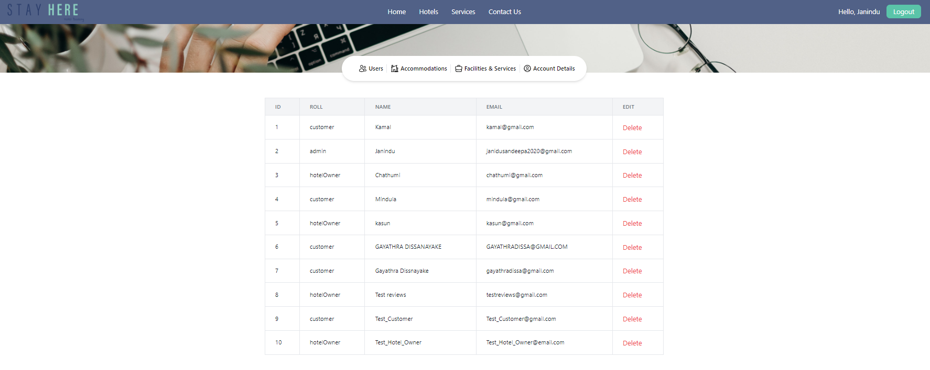

1. 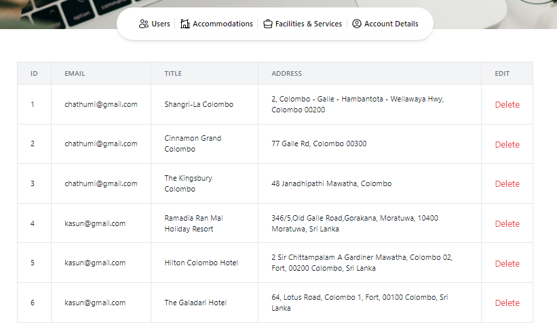View/ Delete Accommodations
2. 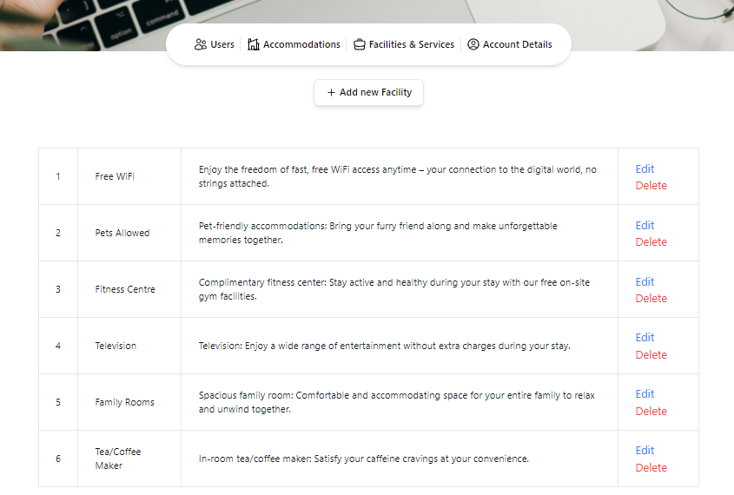View/ Add/ Delete or Edit Facilities

**Contributions**

**CRUD Operations**

1. 21000395 – A. D. N. De Zoysa

* Customer Bookings

1. 21000557 – D. G. D. Dissanayake

* Hotel Services

1. 21001022 – K. A. S. M. Kularathne

* Reviews

1. 21001032 – M. J. S. Kulathilaka

* Accommodations(Hotels)

**Front End:** M. J. S. Kulathilaka, K. A. S. M. Kularathne

**Back End:** A. D. N. De Zoysa, D. G. D. Dissanayake

**Report:** K. A. S. M. Kularathne, A. D. N. De Zoysa

**Video:** D. G. D. Dissanayake, M. J. S. Kulathilaka

**Design:** A. D. N. De Zoysa, K. A. S. M. Kularathne

**Inquiry:** M. J. S. Kulathilaka

**Login/Register:** M. J. S. Kulathilaka, D. G. D. Dissanayake